Report of Software Architecture

Homework 16: Mediator Pattern

Basic information
Team name： _______________________________

Class number: ____________________________________________________
Department/school：
Team members with student numbers：

_______________________

Instructor’s comments and score
comments：

score：
signature of the instructor：

Year month date
Homework Description：See the following class diagram for the Mediator pattern implementation of collaboration program for Hotel, Airline and Tour. 作业描述：酒店、航空公司和旅游合作项目的中介模式实现见下图。
HotelGUI
-mdtr TourMediator
+reserveRoom()
+checkIn()
+checkOut()
+notifyAirline()
+notifyTour()
+display()
TourGUI
-mdtr TourMediator
+reserveRoom()
+checkIn()
+checkOut()
+notifyAirline()
+notifyTour()
+display()
BusinessMediator
hotelGui: HotelGUI;
airlineGui: AirlineGUI;
tourGui: TourGUI
+registerHotelGUI(HotelGUI hg)
+registerAirlineGUI(AirlineGUI ag
+registerTourGUI(TourGUI tg)
+updateAllGuis(String text)
AirlineGUI
-mdtr TourMediator
+reserveRoom()
+checkIn()
+checkOut()
+notifyAirline()
+notifyTour()
+display()

The three user interfaces for the Hotel, Airline and Tour are as below.

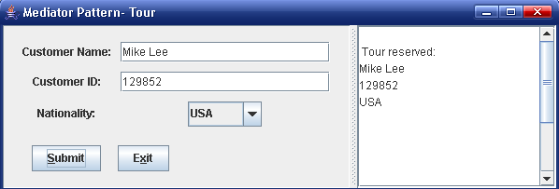
图12.11 旅游公司输入客户信息
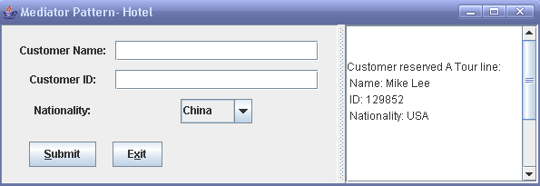
图12.12 宾馆界面同步获得旅游公司输入的客户信息
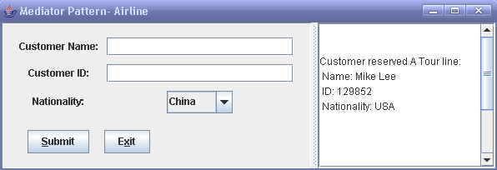
图12.13 机场界面同步获得旅游公司输入的客户信息

Homework requirement:

作业要求：
- Run the program before you go any further
- 在继续之前运行程序
- (Coding) Add another class named TouriststoreGUI such that the 4 classes HotelGUI, AirflightGUI, TourGUI and TouriststoreGUI will interact though the TourMediator in the same way as before (use the mediator pattern). （编码）添加另一个名为TouriststoreGUI的类，这样HotelGUI、AirlightGUI、TourGUI和TouriststoreGUI4个类将通过TourMediator以与以前相同的方式进行交互（使用中介模式）。

- Describe your finished homework, including
    - What classes have been added to the existing class hierarchy?
    - The relationship between the existing classes and the newly added classes.
    - What code has been added to what class?
etc. 1.描述你完成的家庭作业，包括
i.在现有的类层次结构中添加了哪些类？
ii.现有类和新添加类之间的关系。
iii.向哪个类添加了什么代码？
等等

- Draw the final class diagram here
写下你新的类图在这里

3. When you enter all the name, id number, and choose the nationality as China, in HotelGUI, what methods in what class have been invoked, list all of them in correct order. 当您输入所有姓名、身份证号码并选择国籍为中国时，在HotelGUI中，调用了哪个类中的哪些方法，请按正确的顺序列出所有方法。

4. Discussion
- Describe the functionality of the TourMediator class.
- Explain how the mediator pattern works?
讨论
1.描述TourMediator类的功能。
2.解释中介模式是如何工作的？

